1. Virtual Bridge

Bridge is a link layer device and understands link layer protocols and therefore copiesdata frame by frame. In Linux, a bridge is a virtual device. As such, it cannot receive or transmit anythingunless you bind one or more real devices to it.

1. Bridge in linux

Opts of bridge

SIOCBRADDBR create a bridge

SIOCBRDELBRdelete a bridge

SIOCBRADDIF add an interface to bridge

SIOCBRDELIF delete an interface to bridge

1. SIOCBRADDBR

sudo brctl addbr br0 #add br0 bridge in on the host

or

int addBridge(const char *brname)

{

int fd;

if (unlikely(brname == NULL))

return -1;

if((fd = socket(PF_INET, SOCK_DGRAM, 0)) < 0)

{

printf("Error socket :%m\n", errno);

return -1;

}

if(ioctl(fd, SIOCBRADDBR, brname) < 0)

{

printf("Error add bridge %s :%m\n", brname, errno);

close(fd);

return -1;

}

close(fd);

return 0;

}

sock_ioctl-🡪 br_ioctl_deviceless_stub-🡪 br_add_bridge(struct net *net, const char *name)

{

//allocate a net_device for bridge and init it through br_dev_setup . Then register it

dev = alloc_netdev(sizeof(struct net_bridge), name, br_dev_setup);

/* dev->netdev_ops = &br_netdev_ops; in the br_dev_setup*/

res = register_netdev(dev);

}

1. SIOCBRDELBR

sudo brctl delbr br0 #del br0 bridge in on the host

or

int delBridge(const char *brname)

{

int fd;

if (unlikely(brname == NULL))

return -1;

if((fd = socket(PF_INET, SOCK_DGRAM, 0)) < 0)

{

printf("Error socket :%m\n", errno);

return -1;

}

if(ioctl(fd, SIOCBRDELBR, brname) < 0)

{

printf("Error del bridge %s :%m\n", brname, errno);

close(fd);

return -1;

}

close(fd);

return 0;

}

sock_ioctl-🡪 br_ioctl_deviceless_stub-🡪br_del_bridge(struct net *net, const char *name)

{

//get a net_devicefrom name and init it through br_dev_setup . Then register it

dev = __dev_get_by_name(net, name);

if (dev->flags & IFF_UP) {

/* Not shutdown yet. */

ret = -EBUSY;

}

else

br_dev_delete(dev, NULL);}

}

1. SIOCBRADDIF

sudo brctl addif br0 eth0#add eth0 to bridge br0

or

int bridgeAddPort(const char *ifname, const char *brname)

{

int s;

if (unlikely(ifname == NULL) || unlikely(brname == NULL))

return -1;

if((s = socket(PF_INET, SOCK_DGRAM, 0)) < 0)

{

printf("Error up %s :%m\n", ifname, errno);

return -1;

}

struct ifreq ifr;

strcpy(ifr.ifr_name, brname);

if (!(ifr.ifr_ifindex = if_nametoindex(ifname)))

{

printf("Error get %s ifindex :%m\n", ifname, errno);

close(s);

return -1;

}

if(ioctl(s, SIOCBRADDIF, &ifr) < 0)

{

printf("Error add %s to br0 :%m\n", ifname, errno);

close(s);

return -1;

}

close(s);

return 0;

}

sock_do_ioctl-🡪dev->netdev_ops ->ndo_do_ioctl(br_dev_ioctl)-🡪 br_add_if(struct net_bridge *br, struct net_device *dev)

{

/* No bridging of bridges */

if (dev->netdev_ops->ndo_start_xmit == br_dev_xmit)

return -ELOOP;

/* Device is already being bridged */

if (br_port_exists(dev))

return -EBUSY;

/*enable promisc for the eth0 device*/

dev_set_promiscuity(dev, 1);

/*allocate a bridge port*/

struct net_bridge_port *p = new_nbp(br, dev);

/* insert the port to the datebase*/

br_fdb_insert(br, p, dev->dev_addr, 0); // the relevant fdb->is_local set 1

/*set receive hander to br_handle_frame:dev->rx_handler= br_handle_frame*/

netdev_rx_handler_register(dev, br_handle_frame, p);

}

1. SIOCBRDELIF

sudo brctl delif br0 eth0 #add eth0 to bridge br0

or

int bridgeDelPort(const char *ifname, const char *brname)

{

int s;

if (unlikely(ifname == NULL) || unlikely(brname == NULL))

return -1;

if((s = socket(PF_INET, SOCK_DGRAM, 0)) < 0)

{

printf("Error up %s :%m\n", ifname, errno);

return -1;

}

struct ifreq ifr;

strcpy(ifr.ifr_name, brname);

if (!(ifr.ifr_ifindex = if_nametoindex(ifname)))

{

printf("Error get %s ifindex :%m\n", ifname, errno);

close(s);

return -1;

}

if(ioctl(s, SIOCBRDELIF, &ifr) < 0)

{

printf("Error add %s to br0 :%m\n", ifname, errno);

close(s);

return -1;

}

close(s);

return 0;

}

sock_do_ioctl-🡪dev->netdev_ops ->ndo_do_ioctl(br_dev_ioctl)-🡪br_del_if(struct net_bridge *br, struct net_device *dev)

1. Frame handle in Bridge
2. netif_receive_skb(struct sk_buff *skb)

{

/* the packet always deliver to the ptype_all handler*/

list_for_each_entry_rcu(ptype, &ptype_all, list) {

if (!ptype->dev || ptype->dev == skb->dev) {

if (pt_prev)

ret = deliver_skb(skb, pt_prev, orig_dev);

pt_prev = ptype;

}

}

/*handle the device belong to a bridge*/

rx_handler = rcu_dereference(skb->dev->rx_handler);

if (rx_handler) {

switch (rx_handler(&skb)) { /* br_handle_frame is the handle*/

case RX_HANDLER_CONSUMED:

ret = NET_RX_SUCCESS; /*handle by bridge so it will not deliver to others Then out*/

goto unlock;

case RX_HANDLER_ANOTHER:

goto another_round;

case RX_HANDLER_EXACT:

deliver_exact = true;

case RX_HANDLER_PASS:

break;

default:

BUG();

}

}

}

1. Big Map of handler

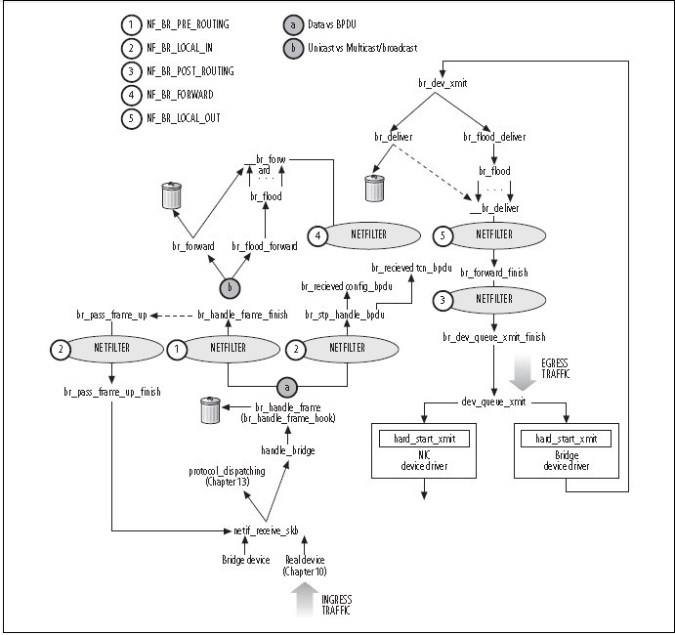

intbr_handle_frame(struct sk_buff *skb)

{

/*get bridge port of the net_device*/

p = br_port_get_rcu(skb->dev);

if (ether_addr_equal(p->br->dev->dev_addr, dest))/*dest is equal to the bridge mac. So it shold send to the host*/

skb->pkt_type = PACKET_HOST;

NF_HOOK(NFPROTO_BRIDGE, NF_BR_PRE_ROUTING, skb, skb->dev, NULL,

br_handle_frame_finish);

}

int br_handle_frame_finish(struct sk_buff *skb)

{

/*update fdatabase to record which port the packet’s sender belong to*/

br_fdb_update(p->br, p, eth_hdr(skb)->h_source, vid);

/*get the dst route from the fdatabase according to dest mac */

if (dst = __br_fdb_get(br, dest, vid)) &&dst->is_local) {

skb2 = skb;/*if dst is local that means the packet is to the host*/

/* Do not forward the packet since it's local. */

skb = NULL;

}

if (skb)

{

if (dst) {

dst->used = jiffies;

/*find the dst and forward it*/

br_forward(dst->dst, skb, skb2);

} else

/*can not find then flood forward it*/

br_flood_forward(br, skb, skb2);

}

if (skb2) /*send to the host*/

return br_pass_frame_up(skb2);

}

int br_forward(const struct net_bridge_port *to, struct sk_buff *skb)

{

/*send the packet through the device of to port*/

skb->dev = to->dev;

skb_push(skb, ETH_HLEN);

br_drop_fake_rtable(skb);

dev_queue_xmit(skb);

}

Int br_pass_frame_up(struct sk_buff *skb)

{

/*change the device to bridge device and send back to the netif_receive_skb */

skb->dev = brdev;

return NF_HOOK(NFPROTO_BRIDGE, NF_BR_LOCAL_IN, skb, indev, NULL,

netif_receive_skb);

}

1. Some tips in practice
2. If a Packet receive from the net_devcie belong to a bridge(bridge packets), the packet will go into the bridge handle.
3. The Dest Mac address of the bridge packets is equal the Mac addr of one of the port(net_device belong to the bridge) of the bridge(including bridge itself). The packet should be the HOST_PACKET and deliver back to the netif_receive_skb.

1) SRC IP: the packet only can be receive when the src ip is in the sub network of the bridge device and can’t be equal to any ip of host device./* for routing reason*/

2) DEST IP: des ip can be any ip of host device(including bridge device), Then the socket in userspace can receive it. It means the packet should for one of the interface aha.

1. If the bridge packets is not in the b situation, the packet will be unique forward or flood forward.